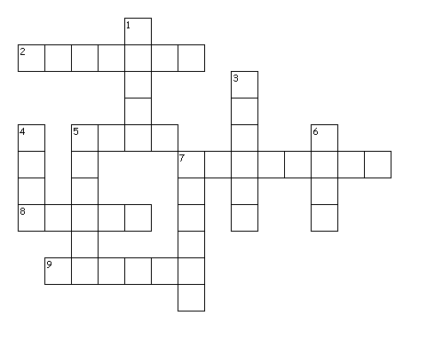
- Fill the criss cross
Across
2. kuchyň
5. pohovka
7. skříňka
8. ručník
9. lednička
Down
1. polička
3. koberec
4. byt
5. sprcha
6. předsíň
7. sporák

_____/11

- Complete the sentences

  - You can have a shower in the _________________________.
  - Put the car in the _______________________.
  - I always sleep in the _______________________.
  - Také off your coat in the ____________________.
  - My mum cooks lunch in the ______________________. _____/5

- Where are these things? (write preposotions)
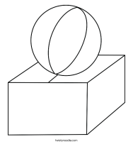
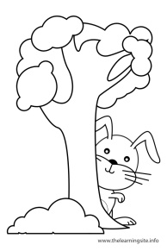
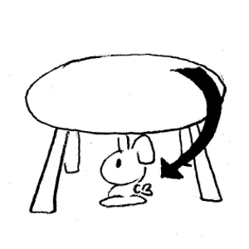
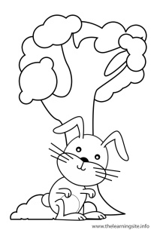

_________ _____________ ________ ____________ ______________ ____________
_____/6
- Complete:
Where ________Vicky live? I don't ________where she _______. She doesn't _________near me.
Do you _________ a musical instrument? No, but my cousin ________.
When ______ you _________ your homework? I don't ____________ it, I'm too lazy.
My cousin _________ the drums. He _____ a famous drummer, he ___________ it very much.
What _______ he _______ in his free time? His hobby_____ film. _____/15
- Complete with do/does

_________________ listen to The Radio Prague? (Janet)
_________________ take the bus to school? (Martin)
_________________ do his homework from five to six o’clock? (he)
_________________ play football? (you)
_________________ play computer games? (they)
_________________ have lunch at one o’clock? (we)
_________________ collect stamps? (she)
____________________________ go skiing? (your parents)
____________________________ play football in the garden? (Tom and John)
_________________ work in a shop? (I)
_________________ go home at five o’clock? (we)
_________________ like pop concerts? (you) _____/12
- Present continuous or present simple?

Hurry! The bus ____________! (come)
Sorry, I cannot hear you. What _______ you _________ about? (talk)
The river Vltava ________ into the river Labe. (flow)
He’s my friend, I __________ him. (believe)
I cannot lend you my laptop, I __________ it at the moment. (need)
I usually _______ to school by bus. (go)
Water _________ at 100 degrees Celsius. (boil)
I usually ___________ concerts but I _____ not _________ this one very much. (enjoy)
The Earth ________ round the Sun. (go)
I _________ you’ll pass the exam. (think)
Look, somebody _____________ up the wall over there. (climb)
Be quiet, please. I ______________. (study)
Where is Anne? She _____________ a bath. (have)
I ________ football every weekend. (play)
John is in Prague, he ____________ with his girlfriend. (stay)
_____/18
Total score:_______/67

